
STANDARD ALERT NOTIFICATION

If an order has been ePrescribed to the incorrect pharmacy, that order cannot be updated to send to another pharmacy. This is due to the order identifier being used by SureScripts and the same identifier cannot be used twice. If you notice that items have been sent to an incorrect pharmacy, please follow the below steps:

- Any order send to the original/incorrect Pharmacy will need to be discontinued
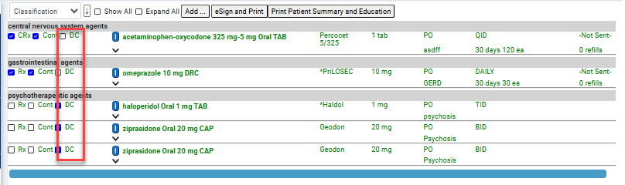
- That pharmacy will need to be called to make sure they received the cancel
- Patient’s preferred pharmacy will need to be updated to reflect the correct pharmacy
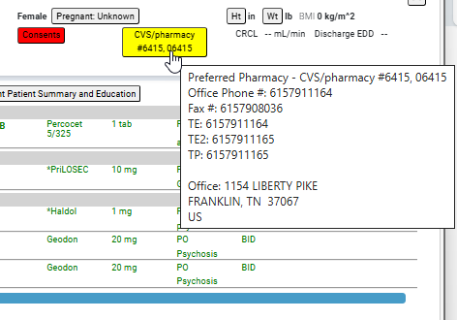
- New orders for the medications will need to be entered and ePrescribed

Please forward this information along to your providers for reference. I will also be creating a document in the Provider folder on our Sharepoint that will have these steps. Below is the path to that Sharepoint for access to the rest of our training manuals and guides.

